TOWN OF HANCOCK
  - P.O. BOX 100
  - HANCOCK, VERMONT 05748
  - TELEPHONE (802)767-3660

Prospectus For Shampeny Hill Road

Ledge Removal/Ditch Cleaning/Shaping and Stone Lining/Culvert Installations

11/21/2024
The Town of Hancock, Vermont is seeking construction bids for ledge removal, ditch cleaning, shaping, lining, and culvert replacements on Shampeny Hill Road in Hancock, Vermont.
Insurance Requirements: The Town of Hancock requires that all Contractors or Persons working for the Town of Hancock carry a General liability Policy of no less than One million Dollars ($1,000,000.00) with the Town of Hancock being an additional Insured. Any Contractor or Persons working for the Town of Hancock having Employees must provide the Town of Hancock with a Certificate of Worker’s Compensation meeting all State of Vermont and Federal Statues. All Insurance Certificates must be on file with the Hancock Town Clerk before work is to begin.
Additional Requirements: The Town of Hancock requires that any Vehicle exceeding the twenty four thousand pound weight limit (24,000) with or without load, obtain an overweight permit. The Town of Hancock has restrictions on its roads and obtaining this permit is the only way to operate legally on the Hancock Road System.
Additional Requirement: The Town of Hancock requires that all construction sites be properly warned with the correct signage and cones.
Additional Requirement: The Town of Hancock requires that the Contractor provide Traffic control as needed.
Contractor Responsibilities: Furnish all Equipment, Materials, Insurances, Labor and Knowledge necessary to complete the project described herein within the timeframe allowed. ** DIG SAFE must be contacted for this project as there are buried wires in the area. **
Town of Hancock’s Responsibilities: Direction so the herein described project can be completed in the timeframe allowed.
Location: The worksite is located approximately .4 miles west on Shampeny Hill Rd. from the intersection of Shampeny Hill Rd. and Tucker Brook Rd. The area to receive ditch work starts at the top of Shampeny Hill Rd. and runs down (east) along the northern side of the road towards Tucker Brook Rd. The worksite is marked at each end with stakes with orange marking tape. The total distance to receive ditch work is approximately 422 linear feet. Worksite start location: 43.932319, -72.871664. Worksite end location: 43.931396, -72.871118.

Materials:
- 2’ minus Erosion Stone (Quantities to be determined by contractor based on drawing provided by the Town of Hancock)
- The Town of Hancock requires that all bare ground including any areas provided for the waste materials from the ditch cleaning be hydroseeded or seeded and mulched with a Contractor’s Mix. All bare ground must be covered post construction.
- Two 24” wide across-the-road culverts.

Description of Work:
Ledge Removal:

Approximately 90 feet below the project start location, the removal of ledge will begin along the north side of Shampeny Hill Road. Ledge will be removed along a continuous 140 linear foot section of the ditch.
Start location of ledge removal: 43.932199, -72.871619
End location of ledge removal: 43.931855, -72.871459
Ledge shall be removed to allow for a ditch to be established along the north side of Shampeny Hill Road. Required ditch dimensions are given in the diagram on the last page of this document.

Ditch Work:
- Contractor shall clean and shape the ditch area. At a minimum, the Town of Hancock requires the base width to be 2’. The depth of the ditch should be 4’ at the center line with the base of Shampeny Hill Rd. as a completion height. Exceptions to these requirements will be considered by the Road Commissioner in the event obstacles are encountered. All stone must be 6” below the edge of Shampeny Hill Rd. See Diagram on last page.
- It shall be the Contractor’s responsibility to remove all excess materials generated from this project.
- Once the ditch has been cleaned and shaped the Contractor shall place 2’ minus ditch stone to a minimum depth of 4’ across the base width, then stone the side slopes of the ditch to the required height.
- Reset any existing bank retaining stones as needed. Any exposed bank soils not covered with retaining stones shall be covered as stated above.
- Culvert inlets and outlets shall be cleaned, shaped, and lined as needed. An exit pad of stone is required. Culvert inlets and outlets shall have stone headwalls.
Culvert Replacement:
- One 24” culvert will be installed at the top of Shampeny Hill Rd. from the project site marking stake (with orange tape) diagonally across the road to the ditch on the south side of Shampeny Hill Rd. on the east side of the snow plow turn around area. Note: This culvert may exceed 40’ in length. The outlet area for this culvert is marked with an orange painted marking stake.
- A second 24” culvert shall be installed to replace an existing 18” culvert at the bottom of the project site. This culvert shall cross the road.

Resolution of Disputes:
The Town of Hancock and the winning Contractor agree to hire an independent arbitrator to settle any and all disputes that may arise. Both parties will share the expense of an arbitrator equally.

Warranty of work performed:
Contractor will guarantee work performed to the full satisfaction of the Hancock Road Commissioner and the Hancock Select Board for a period of not less than one full year (12 months) from the date of the final inspection. This guarantee shall cover all workmanship and any materials the Contractor supplied. In the event of a failure in any of the workmanship or materials, the Contractor will, at their expense, replace or redo any part that has failed and any other damages that may have occurred because of that failure.
This project will be overseen by the Hancock Road Commissioner all inquiries are to be directed to the Road Commissioner (Jim Leno 802-989-4702). If the Road Commissioner is unavailable, you may direct your question to the Hancock Select Board Chair (Scott Gillette 802.770.0727).

Project completion date:
May 31, 2025

Bid Format:
Bid shall be submitted in writing on the attached bid sheet as a single lump sum amount for the project. Bids not conforming to this format shall be rejected.

Bids due:
Tuesday, December 17, 2024, by 3:00 PM at the Hancock Town Clerk’s office.
Bids may be hand delivered to the Hancock Town Clerk’s office for drop off in the outside drop box or Bids may be mailed, so long as they are received any time before 3pm on Tuesday December 17, 2024. All Bids shall be in a sealed envelope marked, Shampeny Hill Rd Ditching / Town of Hancock.
Bids submitted via postal service shall be addressed to Town of Hancock, Shampeny Hill Rd Ditching, PO Box 100, Hancock, VT 05748.
Bids submitted via email or other electronic means shall be rejected.

THE TOWN OF HANCOCK RESERVES THE RIGHT TO REJECT ANY AND ALL BIDS.

By order of the Hancock Selectboard

Bid and Signature Sheet for Hancock Road Projects
__________________________________ submits the following bid based on the prospectus provided by the Town of Hancock. It is further understood that by submitting this bid I/we agree to all the terms described herein. It is furthermore understood that construction projects have many variables and extras and changes may be made as the project proceeds. We agree to work with the Town of Hancock on all changes. We further agree that all changes will be agreed to in writing before any work is to proceed.
BID AMOUNT SUBMITTED:___________________________
DATE:________________________
For Shampenyt Hill Rd Ditch Cleaning / Shaping Project.
Signature of company’s authorized agent:
_________________________________
Bidder’s phone and Email contact information
_________________________________

The Town of Hancock hereby accepts the bid submitted by:
__________________________________ ON _________________
The Hancock selectboard agrees to the terms stated within this prospectus and further agrees that the above named company may begin work as stated within.
Hancock Selectboard:
____________________________
____________________________
____________________________
DATED:_______________
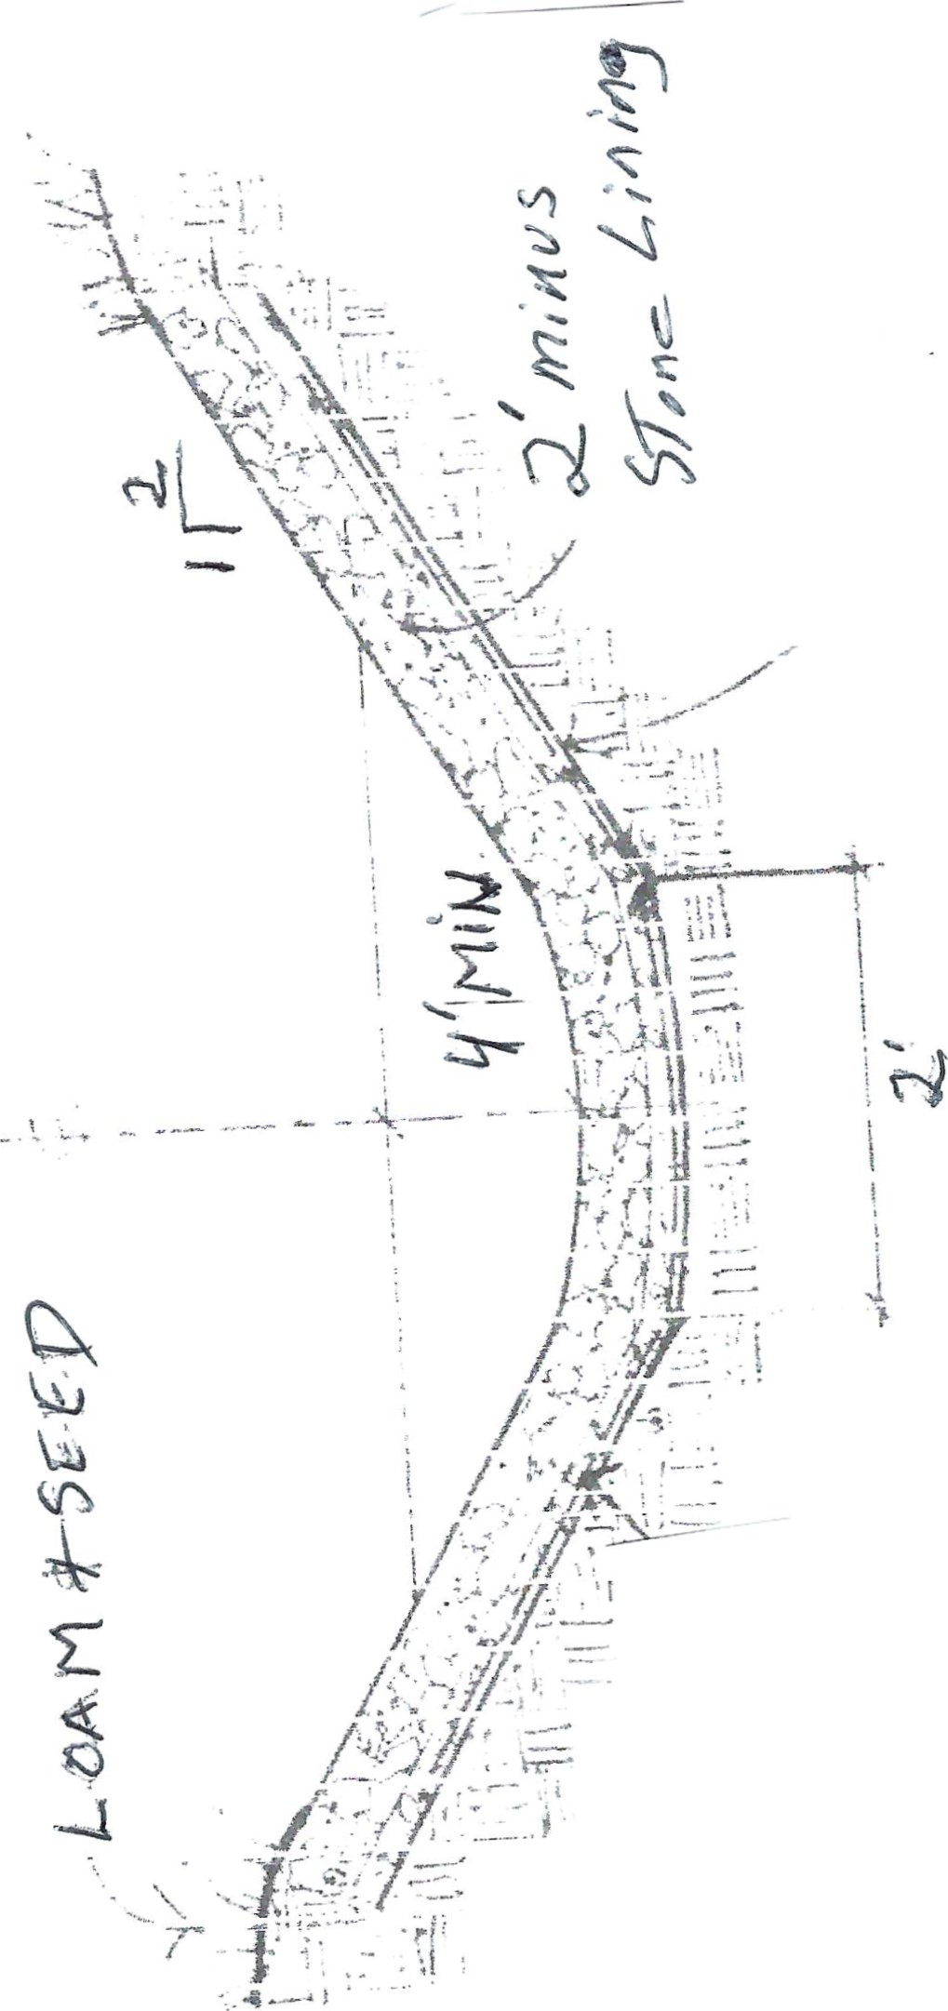
Stone Lined Ditch – Shampeny Hill
2’ minus Erosion/Ditch Lining Stone

